NAME : Debatwik Santra Roll No: CSE/23/110 Exam Roll No : 11600223047 Assignment 2: Create MFA (Multi-Factor Authentication) for authentication.
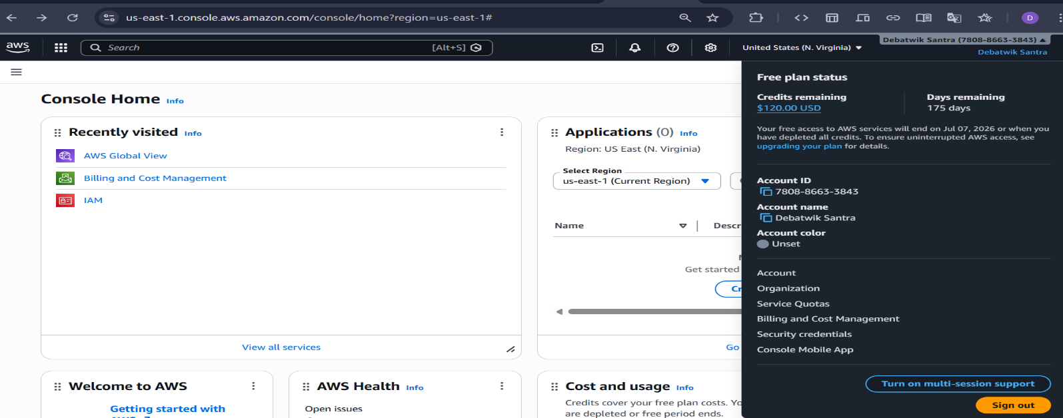
Step1: Log in to your AWS console account, and click on your User_name (Debatwik Santra) to the right top corner and select the ‘Security credentials’.

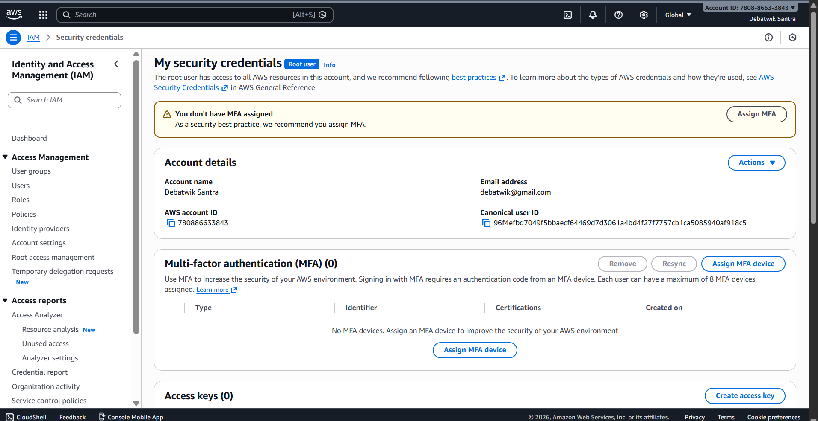
Step2: Click on the ‘Assign MFA device’.

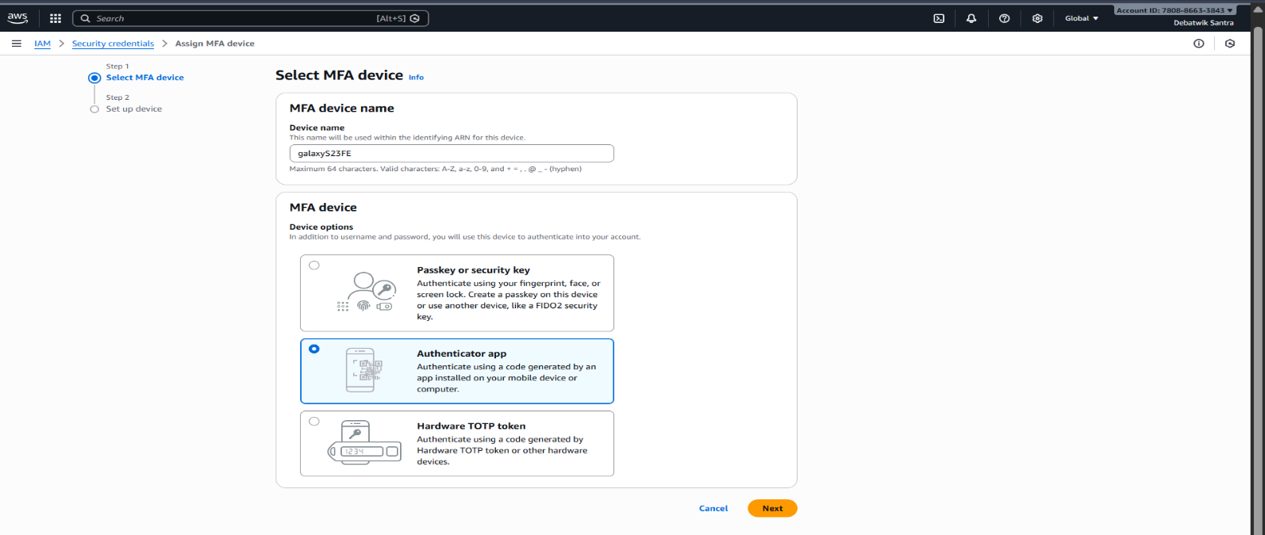
Step3: Give a MFA device name & Select the option ‘Authenticator app’ then click on Next below.

Step4: Open Google Authenticator app in your mobile and scan the QR code using your mobile on that time.
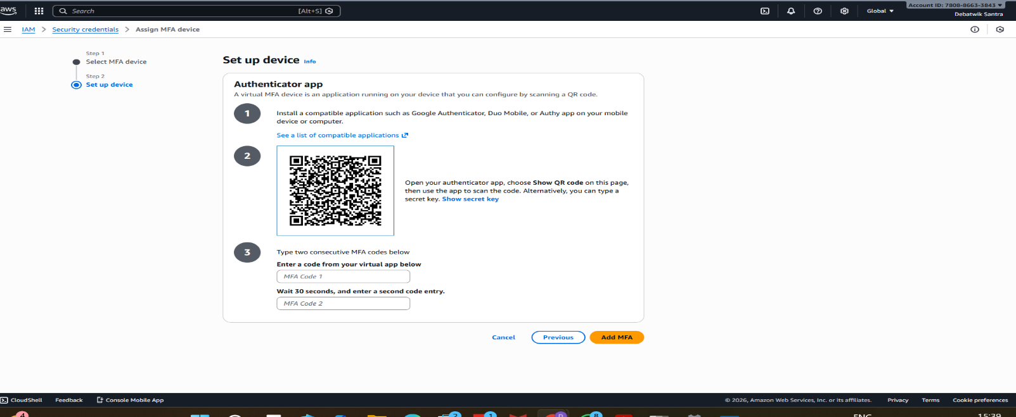
Step5: Fill the ‘MFA Code 1’ & ‘MFA Code 2’ box with two consecutive MFA codes which is showing in your google authenticator app after that then click on the ‘Add MFA’ to complete the process.
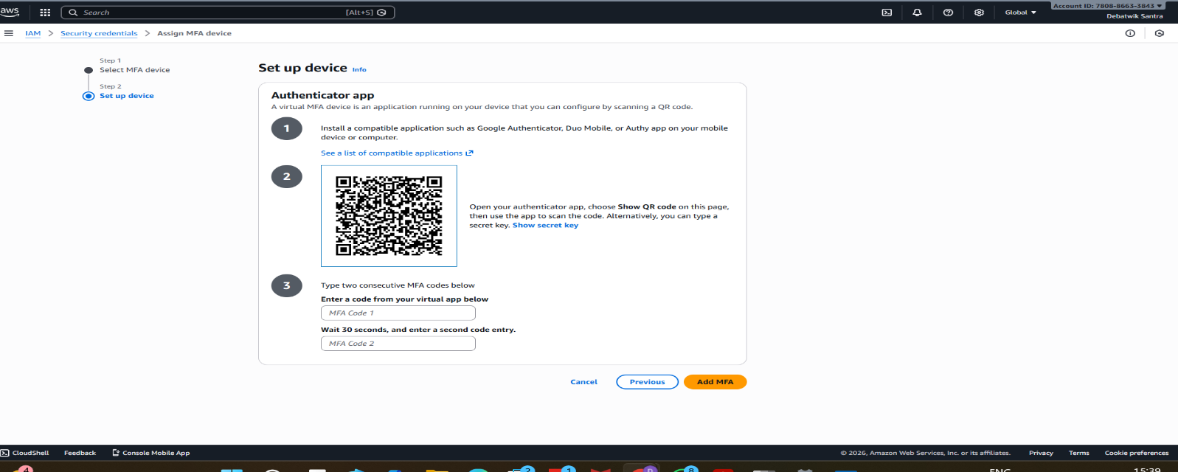
Step6: Here you can see your MFA device has assigned successfully.
